Log of gravity ball training

This is what happened when I restarted the training with a reward about 80 this is for the discrete case with the movement speed of 10

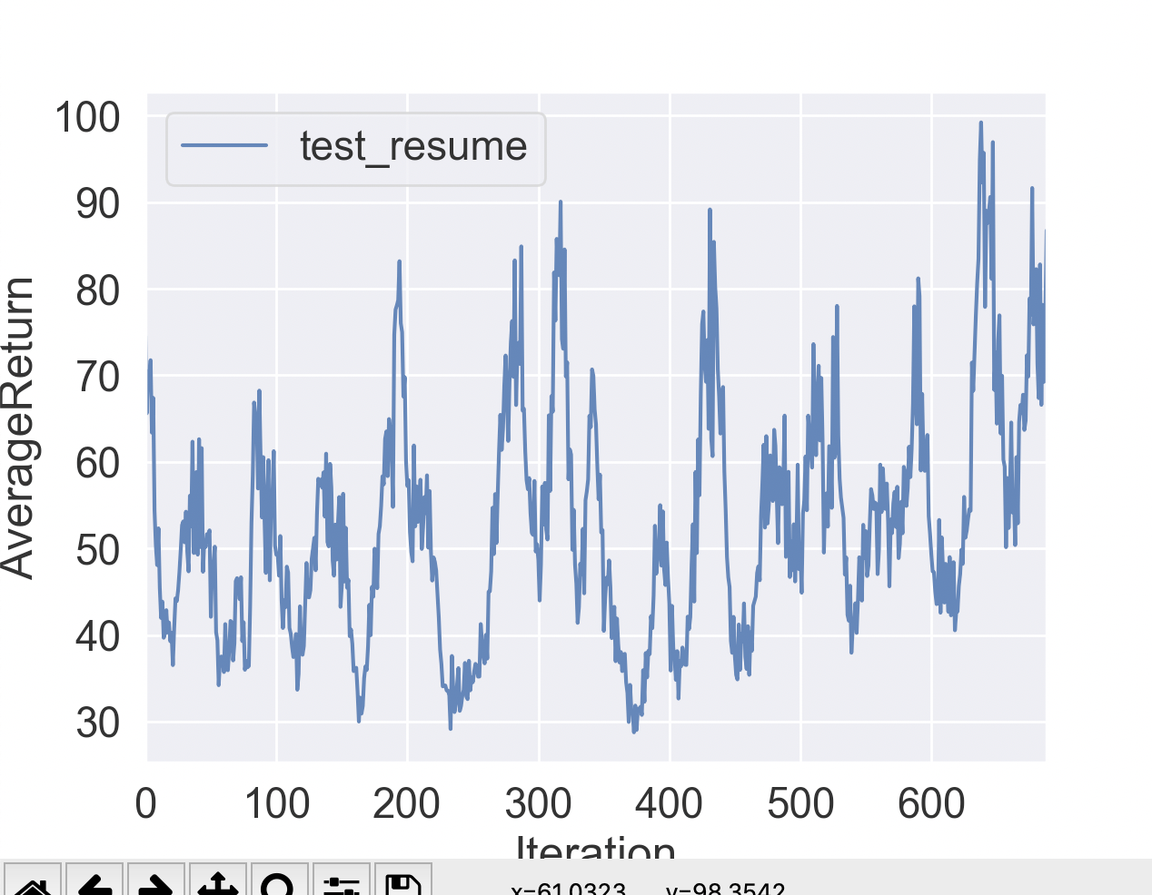

Run that model with

python train_pg_f18.py GB_game -ep 10000 -n 10 -l 2 -s 64 -b 30000 -rc -rp --num_enemies 4 --gb_discrete --output_activation None --render --run_model_only my_save_loc/gcloud/test_resume_GB_game_18-12-2019_19-24-10.ckpt --gb_max_speed 10

It’s beautiful.

After 3k iterations, looks like

And it’s much more beautiful running.

Note that I really need to parallelize the process of generating data. The double cpu doesn’t even run much faster at all!

Now with the more training we’ve got

Trained using: screen python train_pg_f18.py GB_game -ep 10000 --discount 0.99 -n 10000 -l 2 -s 64 -b 100000 -lr 10e-4 --exp_name resume_best_train -rc -rp --save_models --save_best_model --script_optimizing_dir gb_discrete --num_enemies 4 --gb_discrete --output_activation None --gb_max_speed 10 --resume_string my_save_loc/gb_discrete/test_resume_GB_game_18-12-2019_19-24-10.ckpt

Transfer the data stuff w/

matthewhunt@matthews-mbp ~ % gcloud compute scp --recurse instance-1:/home/matthewhunt/deep_rl_course/homework/hw2/data/gb_discrete/resume_best_train_GB_game_20-12-2019_04-11-41 Coding/RL_Stuff/berkley_rl_course/homework/hw2/my_save_loc/gcloud

Ran it with:

python train_pg_f18.py GB_game -ep 10000 -n 10 -l 2 -s 64 -b 30000 -rc -rp --num_enemies 4 --gb_discrete --output_activation None --render --run_model_only my_save_loc/gcloud/resume_best_train_GB_game_20-12-2019_04-11-41.ckpt --gb_max_speed 10

It’s saved in photos and it’s epic.

So now my stuff is actually running in parallel and Ray. Run the following commands to train it without the report Circle, which trains quickly

python train_pg_f18_ray.py GB_game -n 20 -ep 10000 -b 100000 --save_best_model --save_models --output_activation None --parallel --num_enemies 4